**Nextion Multiple Stepper Control Screen Descriptions**

**As used for 2-Axis Driver Board**

**Main Screen**

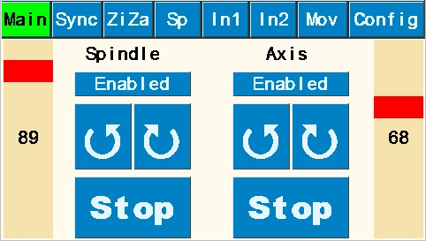

Purpose: Allows direct control of spindle speed and direction and auxiliary axis speed and direction independent of one another. Typically used for continuous spindle and/or continuous Axis motion (turning or facing cuts, continuous rose engine patterns on cylindrical or face surfaces., etc.).

Buttons explanation:

* “Enabled” shows status (either enabled or disabled of stepper motor). If enabled, the motor spindle is in locked status; if disabled, the motor can be repositioned.
* Counterclockwise and clockwise rotational arrows indicate direction of the Spindle and Axis. Rotation continues until “Stop” is pushed.
* Right and left speed bars (for Spindle and Axis, respectively, are shown as a percentage of maximum speeds set on the **Configuration Screen** for “Main” and “Z Axis”, respectively.

**Synchronization Screen**

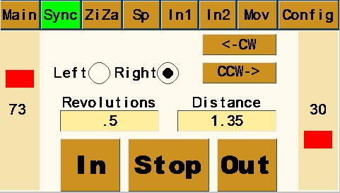

Purpose: Synchronizes the Spindle and Auxiliary Axis to produce helical patterns or threads on cylindrical surface of workpiece or to produce spirals on a face surface.

Buttons explanation:

* “Left” and “Right” determine whether helix runs clockwise or counterclockwise on the piece.
* “<-CW” (Clockwise) and “CCW->” (Counterclockwise) index the spindle for the next cut path – either clockwise or counterclockwise per user design. Amount the spindle will index uses the value in “Size” set in the box on the **Index #1 Screen** (this value could be either in divisions of a circle or degrees depending upon which option is toggled on **Index #1 Screen**).
* “Revolutions” variable value determines how far around the piece the helix will travel based on the spindle rotating. The value of .5 illustrated will rotate spindle 360x.5=180 degrees.
* “Distance” variable value determines the cut length (amount of Z axis movement) and is dependent upon value entered in **Setup Screen** for “Distance/360”.
* Right and left speed bars (for Spindle and Axis, respectively, are shown as a percentage of maximum speeds set on the **Configuration Screen** for “Sync” and “Z Axis”, respectively. Note that slowest value on speed bars will “control” the other value.
* “In” and “Out” determine whether cut is made toward or away from headstock. Pattern will run the pre-determined “Distance” and then stop and wait for return direction instruction. User chooses whether to cut in both directions or retract cutter and return to start without cutting.
* **Warning Note**: If “Stop” is pushed, the program will stop at that point and reset the pattern start point to that spot. In other words, controller will lose track of the start point.

**Zigzag – Axis Screen**

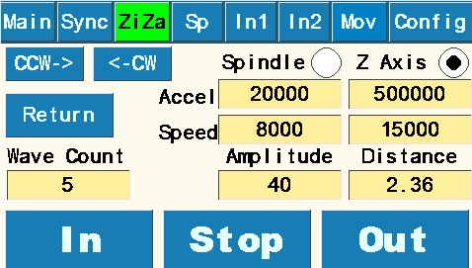

Purpose: Synchronizes Spindle and Auxiliary Axis to produce a sharp-pointed reciprocating “zigzag” pattern along the longitudinal cylindrical surface of workpiece: /\/\/\/\/\/\. Works by reversing spindle direction alternately while Z axis continues in the same direction.

Buttons explanation

* “Z Axis” toggled on is the default screen under the ZiZa header. Toggle to “Spindle” for **ZigZag - Spindle Screen** (see below) Spindle and Z Axis radio buttons control which page is active.
* “<-CW” (Clockwise) and “CCW->” (Counterclockwise) index the spindle for the next reciprocating cut path – either clockwise or counterclockwise per user design or desire. Amount the spindle will index uses the value set in the “Size” box on the **Index #1 Screen** (this value could be either in divisions of a circle or degrees depending upon which option is toggled on **Index #1 Screen**).
* “Acceleration” and “Speed” values for this screen are set here for both Spindle and Z Axis. See notes on value limitations under **Configuration Screen** explanation. Because of synchronization of the spindle and Z Axis speeds, one of the maximum speeds will control the other.
* “Wave Count” variable sets number of individual waves /\ to be cut along the cylinder.
* “Amplitude” variable sets “height” of each wave in degrees of rotation.
* “Distance” variable value determines the cut length for entire pattern (amount of Z axis movement) and is dependent upon value entered in **Setup Screen** for “Distance/360”.
* “In” and “Out” determine whether cut is made toward or away from headstock. Pattern will run the pre-determined “Distance” and then stop and wait for return direction instruction. User chooses whether to cut in both directions or retract cutter and return to start without cutting.
* **Warning Note**: If “Stop” is pushed, the program will stop at that point and reset the pattern start point to that spot. In other words, controller will lose track of the start point.

**Zigzag – Spindle Screen**

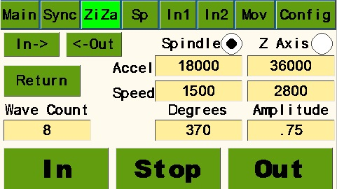

Purpose: Synchronizes Spindle and Auxiliary Axis to produce a sharp-pointed reciprocating “zigzag” pattern along the circumferential surface of a cylindrical workpiece: Works by reversing Z axis direction alternately while spindle continues in the same direction.

Buttons explanation

* To navigate to this screen, start with “Rec1” and toggle from (default) “Z Axis” to “Spindle”.
* “In->” and “<-Out” move the Z Axis to the next pattern starting position. Z Axis movement will be the value of “Distance” set on the **Move Screen.**
* “Return” button rotates the spindle to the pattern start point.
* “Acceleration” and “Speed” values for this screen are set here for both Spindle and Z Axis. See notes on value limitations under **Configuration Screen** explanation. Because of synchronization of the spindle and Z Axis speeds, one of the maximum speeds will control the other.
* “Wave Count” variable sets number of individual waves ( > ) to be cut along the cylinder.
* “Degrees” variable sets the circumferential distance around the cylinder for the total pattern. Entering 360 would wrap the pattern all the way around the cylinder; entering 90 would condense the whole pattern around just 90 degrees of the cylinder.
* “Amplitude” variable sets “height” (distance along Z Axis) of each wave and is dependent upon value entered in **Setup Screen** for “Distance/360”.
* “In” and “Out” determine whether cut is made VERIFY THIS: ARE IN AND OUT ACTUALLY CW or CCW MOVEMENT OF THE SPINDLE????? Pattern will run the pre-determined “Degrees” around spindle and then stop and wait for return direction instruction. User chooses whether to cut in both directions (either on the same cut path or on subsequent path) or retract cutter and return to start without cutting.
* **Warning Note**: If “Stop” is pushed, the program will stop at that point and reset the pattern start point to that spot. In other words, controller will lose track of the start point.

**Spindle Screen**

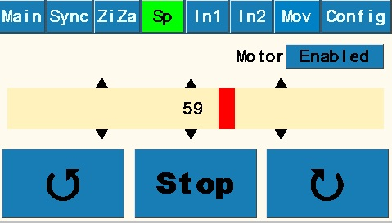

Purpose: Allows control of spindle speed and direction. Useful for allowing manual control of the Z Axis (or other movement) while spindle rotates to set speed and direction. Also useful for secondary spindle operation such as higher or lower speed functions than the **Main Screen**.

Buttons explanation

* “Enabled” shows status (either enabled or disabled of stepper motor). If enabled, the motor spindle is in locked status; if disabled, the motor can be repositioned.
* Counterclockwise and clockwise rotational arrows indicate direction of the Spindle. Rotation continues until “Stop” is pushed.
* Speed bar is shown as a percentage of maximum speeds set on the **Configuration Screen** for “Sp2”.

**Index #1 Screen**

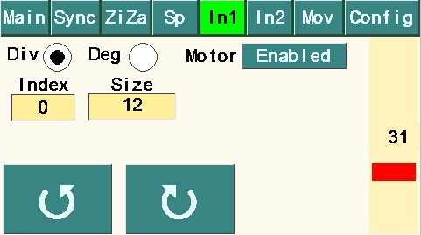

Purpose: Allows indexing spindle for use in index work or other uses.

Buttons explanation

* “Div” toggle sets the indexing to number of divisions of a full rotation. “Deg” toggle sets the indexing to number of degrees.
* “Enabled” shows status (either enabled or unenabled of spindle stepper motor). If enabled, the motor spindle is in locked status; if unenabled, the motor can be repositioned. If repositioned, and then re-enabled, all subsequent indexing will use that point as the new point.
* “Index” box keeps a running “count” of the number of indexing moves.
* “Size” variable is in either Divisions of a circle of Degrees, depending upon which is toggled.
* Speed bar is shown as a percentage of maximum speeds set on the **Configuration Screen** for “Index”.
* Note that the “Size” value on the **Index #1 Screen** is used by the “<-CW” and “CCW->” indexing movements on the **Synchronization Screen** and the **Zigzag – Axis Screen** in either “Divisions” or “Degrees”.

**Index #2 Screen**

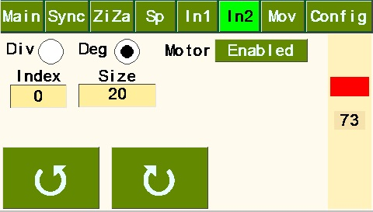

Purpose: Allows indexing spindle for use in index work or other uses. Since it’s independent from other screens, it can be useful secondary index function between patterns created by other screens that use the values in the **Index #1 Screen**.

Buttons explanation

* “Div” toggle sets the indexing to number of divisions of a full rotation. “Deg” toggle sets the indexing to number of degrees.
* “Enabled” shows status (either enabled or disabled of stepper motor). If enabled, the motor spindle is in locked status; if disabled, the motor can be repositioned. If repositioned, and then re-enabled, all subsequent indexing will use that point as the new point.
* “Index” box keeps a running “count” of the number of indexing moves.
* “Size” variable is in either Divisions of a circle of Degrees, depending upon which is toggled.
* Speed bar is shown as a percentage of maximum speeds set on the **Configuration Screen** for “Index”.

**Move Screen**

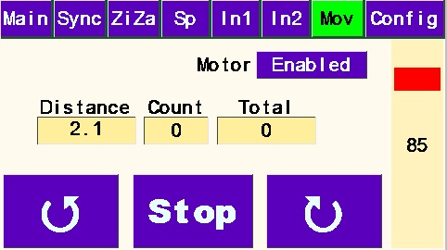

Purpose: Moves the Z Axis a specific distance and direction to produce basket weave or other repeating design element on the cylindrical surface of the workpiece. Could be used to plunge in and out of cylindrical surface to do index work. Could also be used on end face of cylinder if set up to drive X Axis.

Buttons explanation:

* “Enabled” shows status (either enabled or disabled of stepper motor). If enabled, the motor spindle is in locked status; if disabled, the motor can be repositioned.
* “Distance” variable sets amount of movement along Z Axis and is controlled by **Setup Screen** Value “Distance/360”.
* “Count” tracks the number of moves.
* “Total” tracks total distance of movement. VERIFY!
* Counterclockwise and clockwise rotational arrows indicate direction of the Axis movement. Rotation continues until “Stop” is pushed. WOULDN’T IT MAKE SENSE TO USE RIGHT AND LEFT ARROWS OR “IN & OUT” FOR THIS SCREEN?
* Speed bar is shown as a percentage of maximum speed set on the **Configuration Screen** for “Z Axis”, VERIFY?

**Configuration Screen**

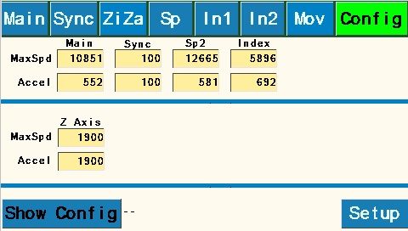

Purpose:

Buttons explanation

* Set “MaxSpd” and “Accel” values for each of the screens listed. If you use different pieces of apparatus (such as a cross-slide, a spherical or a curvilinear apparatus) with the Z Axis settings, it may be desirable to reset the MaxSpd for some uses. Generally speaking, the “MaxSpd” settings can be set anything between 100 and 50000 with 10000 being a safe starting point.  Acceleration can be set between 100 and 500000 with 1000 being a good starting point.
* “Show Config” runs a routine to ~~go through each of the values entered in the boxes on the screen and sends them to the Teensy processor’s onboard memory and~~  return the current settings stored on the Teensy. Settings are also stored on the Nextion and can be out of sync when new software is loaded on either the Teensy or the Nextion. Running “Show Config” should be done each time ~~a change is made to the~~ **~~Configuration Screen~~** ~~including~~ when loading new software into either Teensy or the Nextion. VERIFY AND EDIT?
* “Setup” activates the **Setup Screen**.

**Setup Screen**

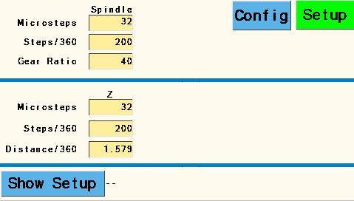

Purpose: The factors on this screen control how speeds and distances are determined.

Buttons explanation:

* Software is currently set up for 32 Microsteps, 200 Steps/360, and 9 Gear Ratio for the spindle.  This assumes a stepper motor with 200 steps per revolution. Note that the standard configuration for the MDF Rose Engine with a 12 tooth spindle motor drive pulley and 108 tooth driven pulley and yields a Gear Ratio of 9 ~~(not 40 as illustrated above).~~ Once set, the values for the Spindle will most likely remain the same unless changes are made to spindle drive setup.
* Likewise, software assumes that Z axis is 32 Microsteps, and that you are using a stepper motor with 200 Steps/360. The 32 and 200 values for Axis will most likely remain the same.
* The “Distance/360” is the distance the Z axis carriage moves in one revolution of its stepper motor. It is a value arrived at empirically by measuring the movement of the Z Axis using a dial indicator or other appropriate device while the stepper motor revolves a set number of turns. This can be accomplished by entering a value in “Distance/360” such as 1, then using the **Move Screen** to move a “Distance” of 20 while measuring. This should turn the motor through 20 full revolutions. Divide the distance traveled by 20 and enter calculated value into “Distance/360”. If the total distance moved in 20 revolutions is insignificant, use a larger “Distance” number like 50. Note that best practice is to remove backlash from the Axis mechanism prior to the measurement run by moving the axis in the same direction. It may be possible to get a starting point for Distance/360 by calculation calculating the stepper pulley to driven pulley ratio, and/or the thread pitch.

Finally, it’s important to note that if you use different pieces of apparatus (such as a cross-slide, a spherical or a curvilinear apparatus) with the Z Axis, each will likely have a different value for Distance/360.

* “Show Setup” See Config page “Show Config” description.~~runs a routine to go through each of the values entered in the boxes on the screen and sends them to the Teensy processor’s onboard memory and should be done each time a change is made to the~~ **~~Setup Screen~~** ~~including when loading new software into either Teensy or the Nextion.~~ VERIFY AND EDIT?
* “Config” button returns you to the **Configuration Screen**.

**Clarification Notes:**

1. X and Z axes for the lathe in descriptions above use the standard shown here:

